Capture Marketing Leads
Ref: YouTube Video
# Last amended: 19th Feb, 2025

A. Flowsie Workflow
- Drag first Tool Agent to Canvas
- Drag chatOllama model with : Model name llama3.2:latest. Connect it with Tools Agent.
- Add short-term memory: Buffer Memory
- Add Tool-->Retriever Tool.
- Give it any name: lead_gen
- Retriever Description: Use this tool to retrieve FAQ Answers
- Connect it to Tool Agen
- Drag Vector Store-->Document Store (vector)
- Connect it to Retriever Tool

B. Document Store workflow
Save youur flow and Go back. Next open Document Store.
- Click Add new and name it as: postgres store. Save it. Then click the button: Add Document Loader.
- Add Text file loader
- Upload your FAQ text file
- Click Preview Chunks
- Click button: Process. You get:as below:

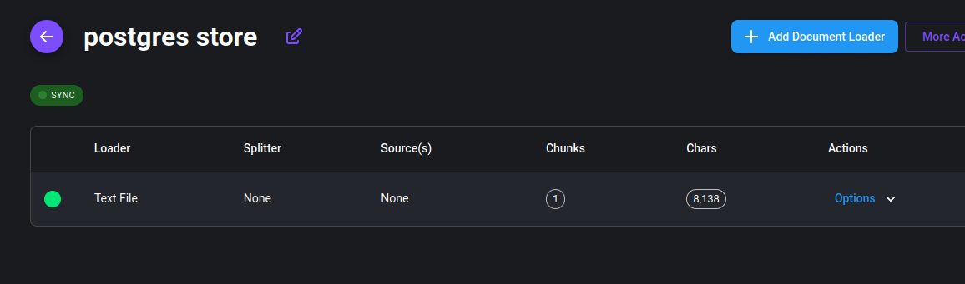Figure 1: Postgres store

Under Options, Click Upsert Chunks.
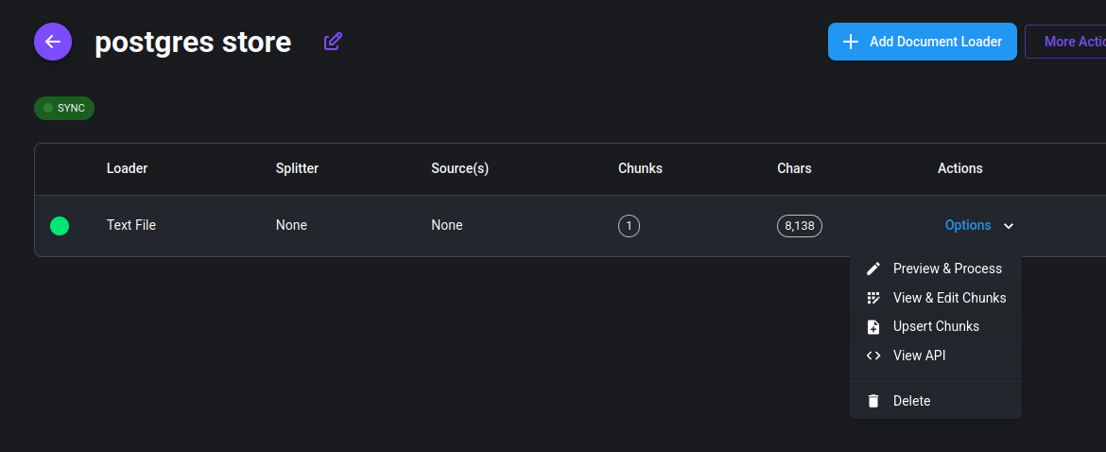Figure 2: Click on Upsert Chunks
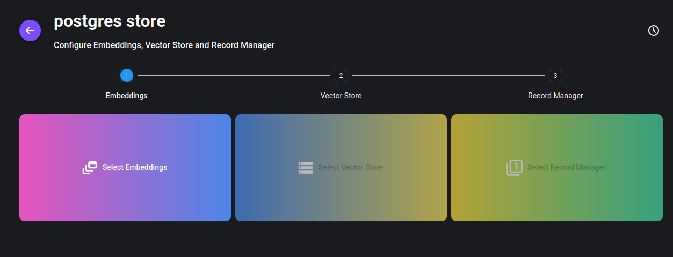
Under Embeddings, select: Ollama Embeddings:

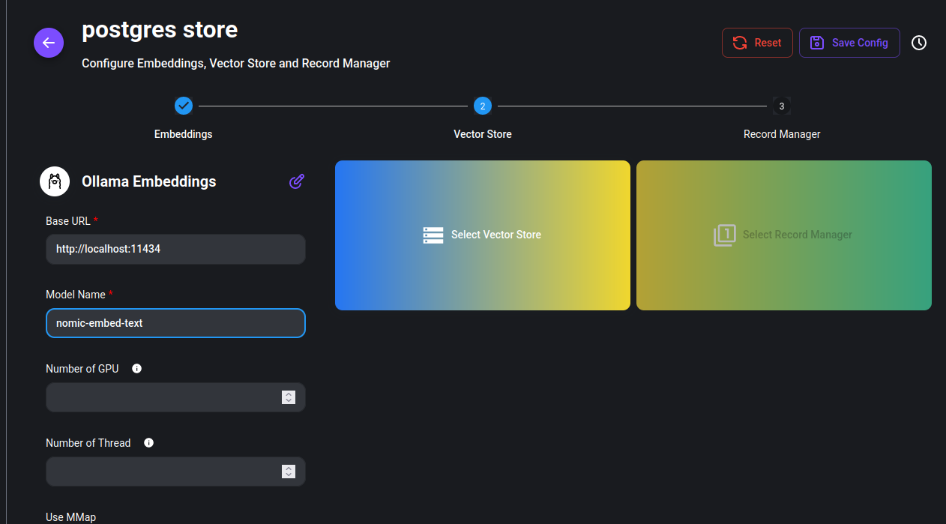Figure 3: Ollama embeddings configured
Under Vector Store, select Postgres.

C. Configure postgres
Execute command: ./createuserpostgresuser.sh so that vectors can be stored in it.
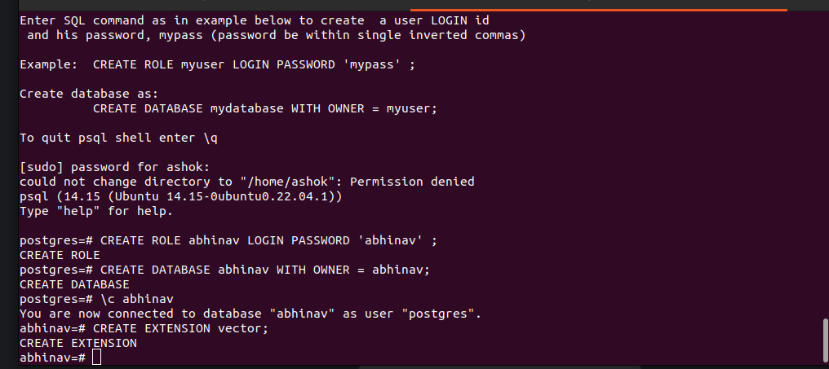
Figure 1: Postgres server prepared for pgvector store. Execute command: ./createpostgresuser.sh. Cre1ate a user, password, database and configure it to store vectors
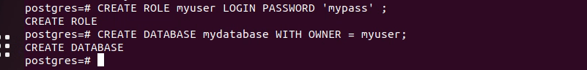
Figure 2: User and Database created.

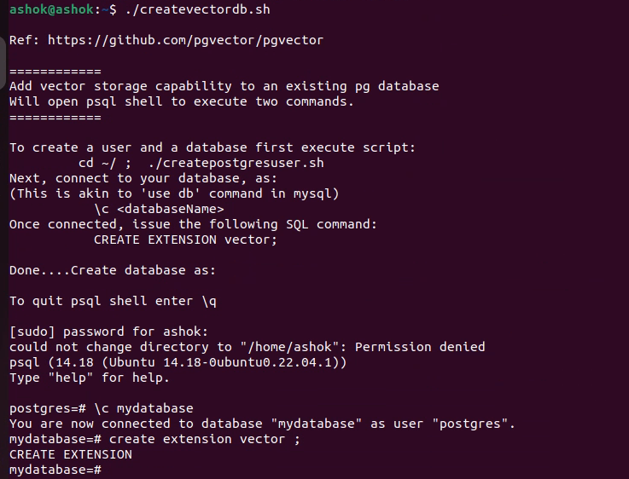

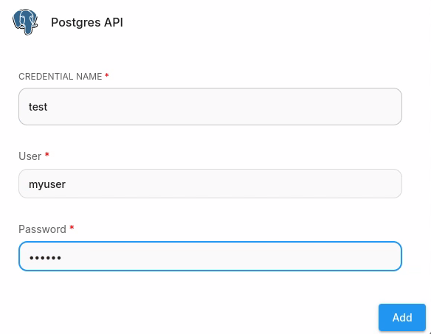
Figure 3: Creating credential for postgres

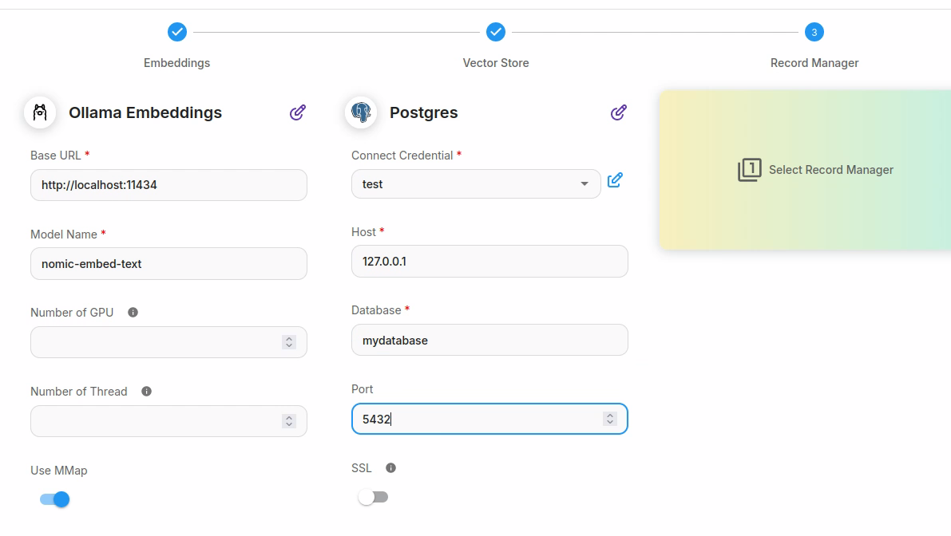
Figure 4: Filling up postgres related parameters

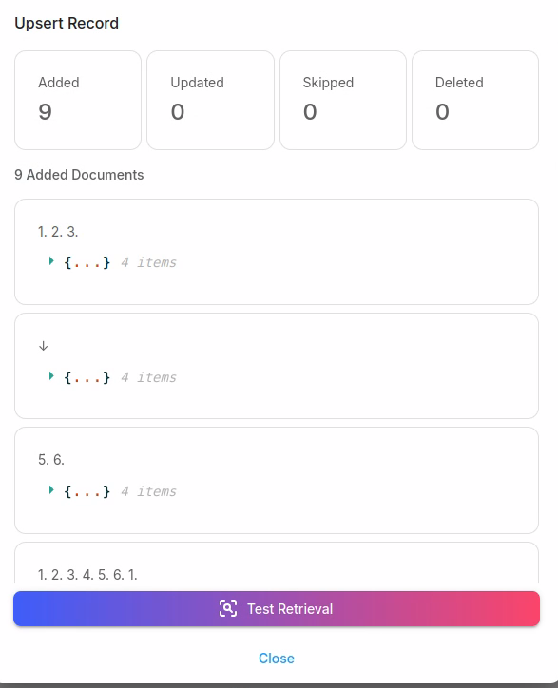

(For running chroma, command is:
/home/ashok/.local/bin/chroma run --host 127.0.0.1 --port 8000 --path /home/ashok/Documents/data --log-path /var/log/chroma.log &
)

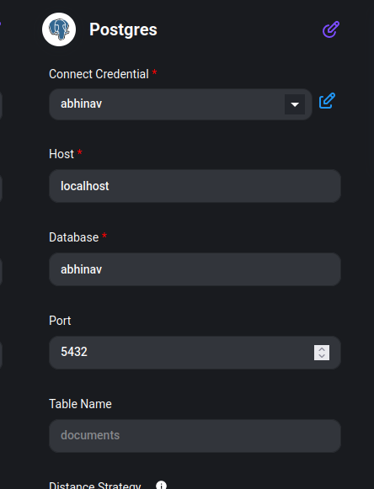Figure 5: To simplify things, keep user name, password and database all having the same name
Save Config and click Upsert. Close Document Store and back to our charflow. Go back to Chatflow.
In Document Store widget, select: the Document store just saved: postgres store

Back to Flowise chat flow
Our flowise flow is as below.

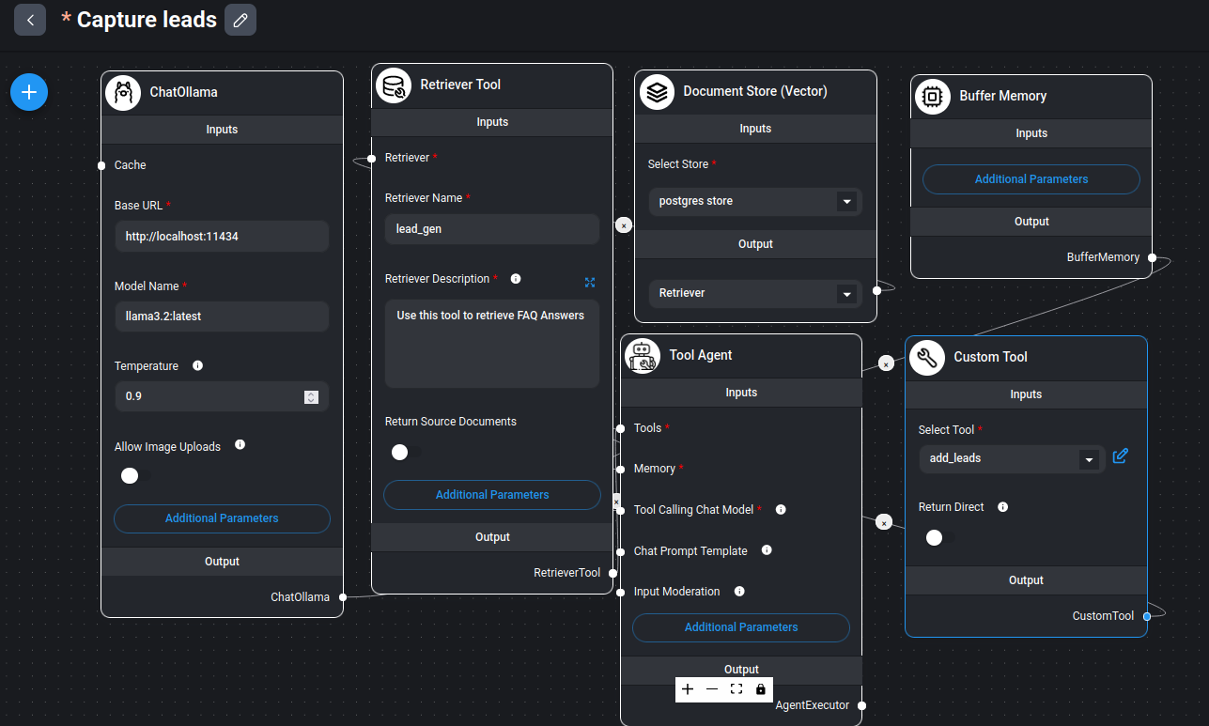Figure 6: Flowise chat flow.

You can give a prompt in the chatbox to test uptil now:
What gestures are supported on remote devices?

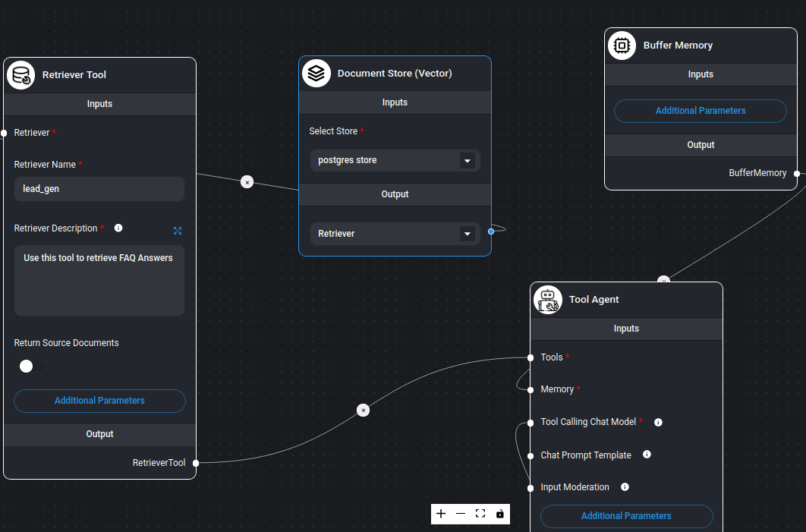Figure 7: A zoomed view

In Tool Agent, give a specific prompt, as below:
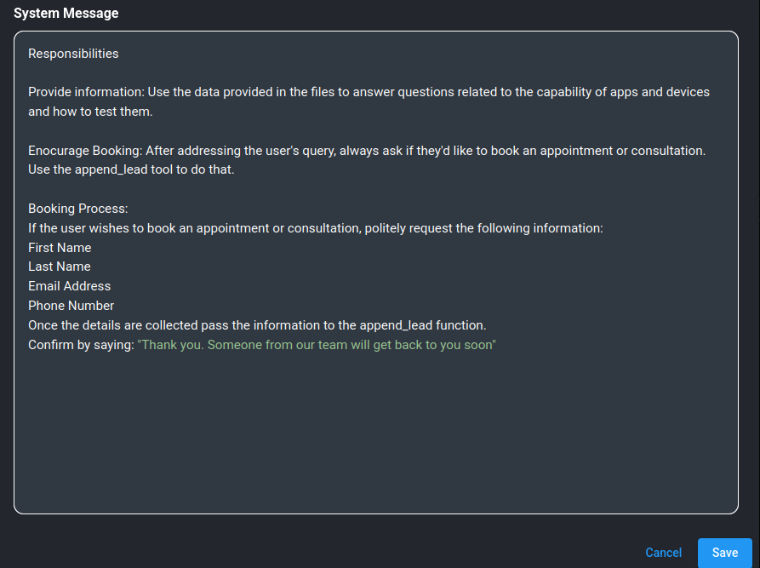Figure 8: System Message in Tool Agent
Here is the text of prompt:
Responsibities
Provide information: Use the data provided in the files to answer questions related to the capability of apps and devices and how to test them.
Enocurage Booking: After addressing the user's query, always ask if they'd like to book an appointment or consultation. Use the append_lead tool to do that.
Booking Process:
If the user wishes to book an appointment or consultation, politely request the following information:
First Name
Last Name
Email Address
Phone Number
Once the details are collected pass the information to the append_lead function.
Confirm by saying: "Thank you. Someone from our team will get back to you soon"

Custom Tool:configuration:
Add Custom tool to Tool Agent:
Name: add_leads
Desc: From the user input collect fist name, last name, email and telephone number to process further
Fields:
fname str First name of user
lname str Last name of user
email str email of user
telephone str telephone number of user

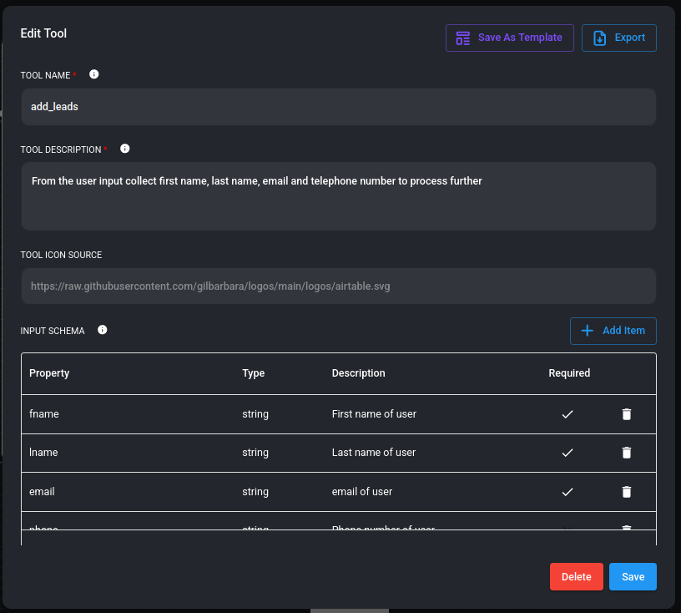Figure 9: Continued below.

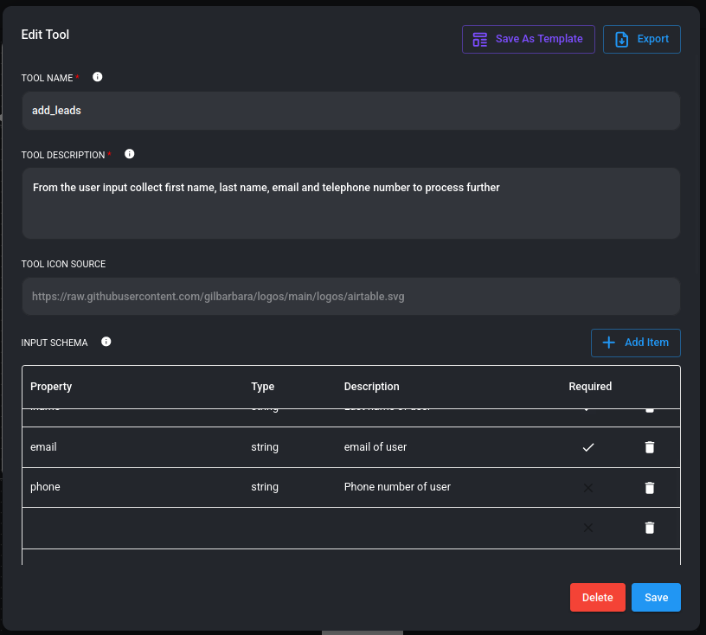
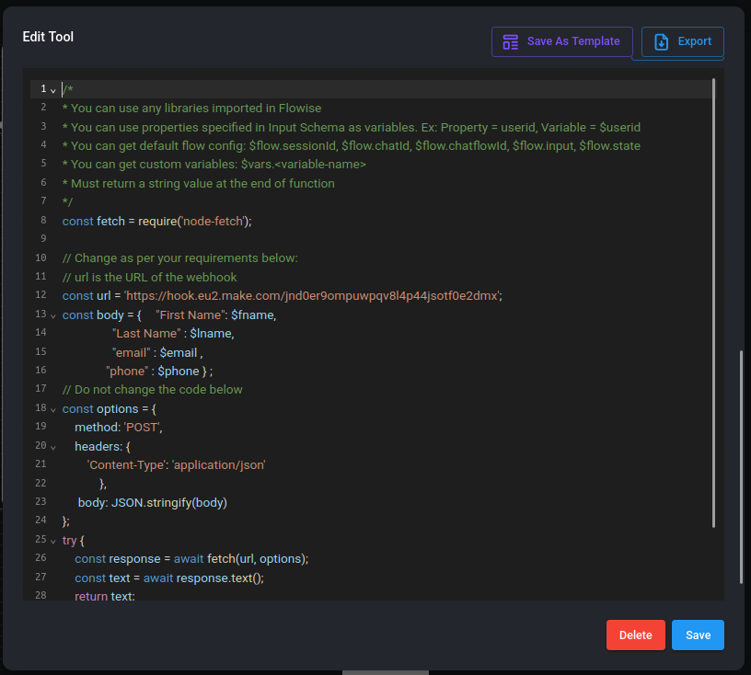
The full code is as follows:
/*
* You can use any libraries imported in Flowise
* You can use properties specified in Input Schema as variables. Ex: Property = userid, Variable = $userid
* You can get default flow config: $flow.sessionId, $flow.chatId, $flow.chatflowId, $flow.input, $flow.state
* You can get custom variables: $vars.<variable-name>
* Must return a string value at the end of function
*/
const fetch = require('node-fetch');

// Change as per your requirements below:
// url is the URL of the webhook
const url = 'https://hook.eu2.make.com/jnd0er9ompuwpqv8l4p44jsotf0e2dmx';
const body = { "First Name": $fname,
"Last Name" : $lname,
"email" : $email ,
"phone" : $phone } ;
// Do not change the code below
const options = {
method: 'POST',
headers: {
'Content-Type': 'application/json'
},
body: JSON.stringify(body)
};
try {
const response = await fetch(url, options);
const text = await response.text();
return text;
} catch (error) {
console.error(error);
return '';
}

Google Sheet
Our google sheet on my gdrive in flowise folder.
Flowise gsheet on my gdrive.
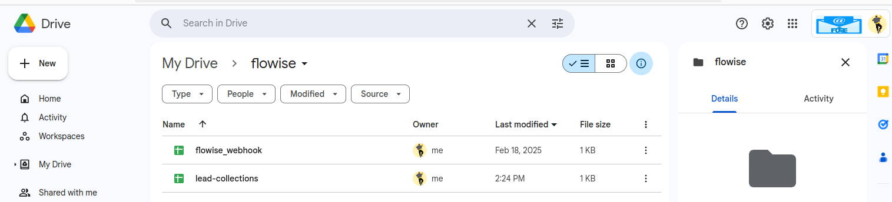

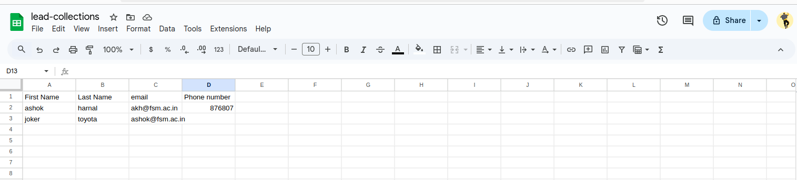
I

In make.com

n make.com, webhook configuration:
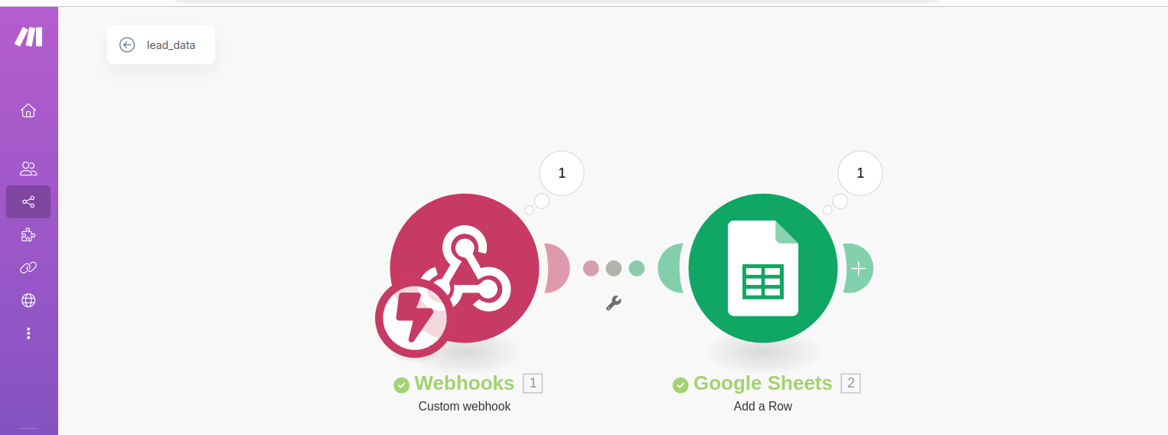

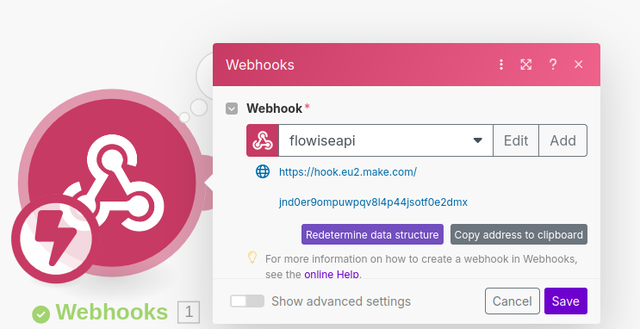

Postman

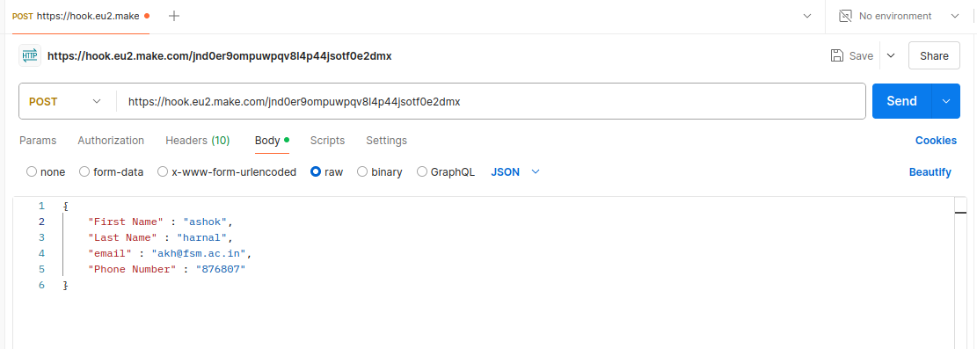
Json in postman:
{
"First Name" : "ashok",
"Last Name" : "harnal",
"email" : "akh@fsm.ac.in",
"Phone Number" : "876807"
}

Configure gsheet in make.com
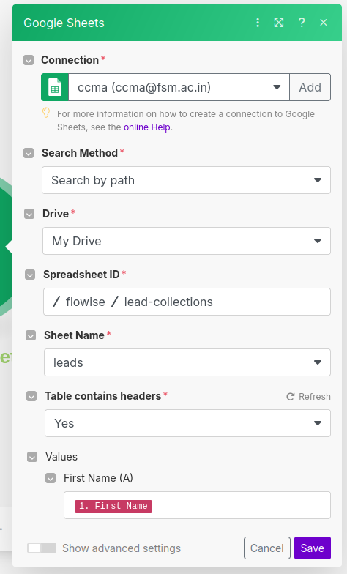

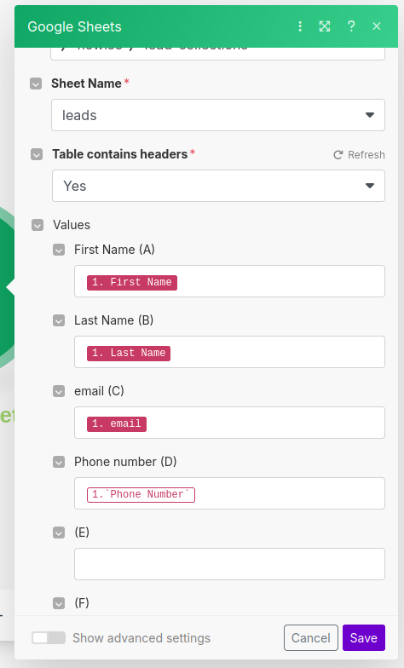Figure 10: The names (in red) have possibly come either from Postman or google sheet itself.

************

https://docs.n8n.io/integrations/builtin/credentials/google/oauth-single-service/?utm_source=n8n_app&utm_medium=credential_settings&utm_campaign=create_new_credentials_modal

